# Flow 1

## Week 1

**19-08-2019**

Vagrant Ubuntu with MySQL and Tomcat up and running on local Windows machine

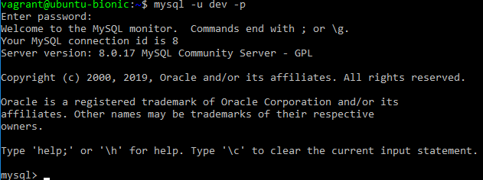

Netbeans 11.1 connected to MySQL on localhost

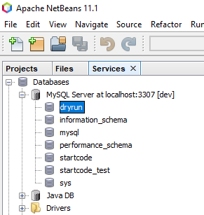

Maven 3.6.1 installed on local machine and configured in Netbeans

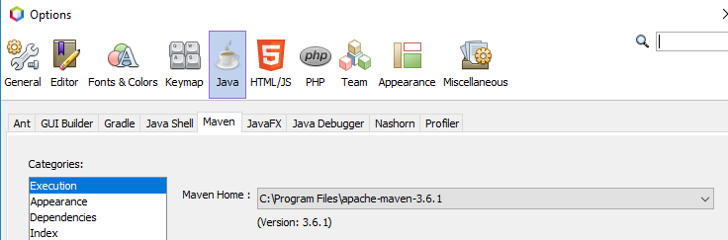

Git cloned jpa-test and

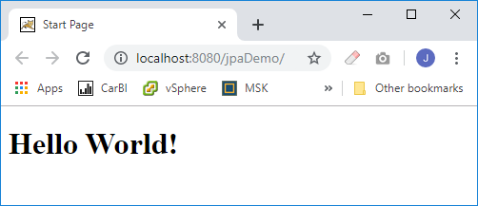

Changed the schema to jpasimple and ran script.sql in MySQL Workbench and created schema and tables

Changed persistence.xml fil to reflect correct schema and user login

